# **Macro Keyboard**

## Arduino Micro Pinouts

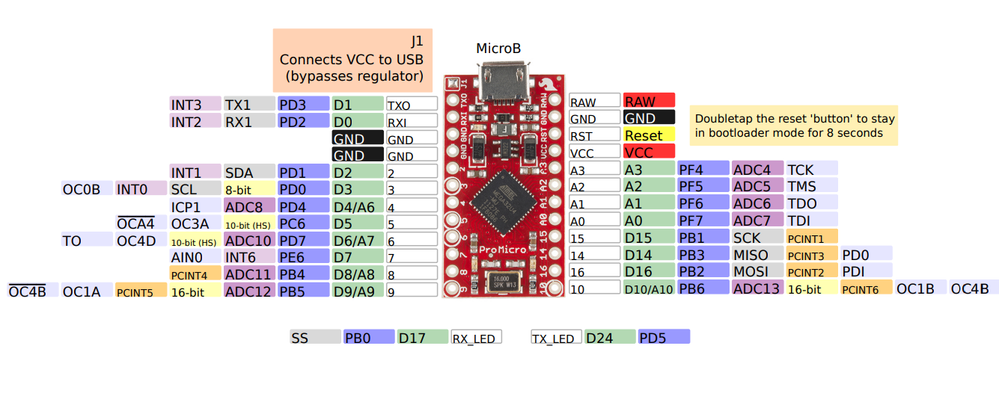

## Keyboard Pinouts

|  |  |
| --- | --- |
| 1 Switch | A0 |
| 2 Switch | A1 |
| 3 Switch | A2 |
| 4 Switch | D15 |
| 5 Switch | D14 |
| 6 Switch | D16 |
| Mode Switch | D5 |
| Scroll Switch | D4 |

## Bi-Colour LED

|  |  |
| --- | --- |
| 1 colour | D7 |
| 2 colour | D8 |

## RGB LED

|  |  |
| --- | --- |
| 1 colour | D6 |
| 2 colour | D9 |
| 3 colour | D10 |

## Interuppt Pins

|  |  |
| --- | --- |
| A | D3 |
| B | D2 |